**Business Analysis Report**

**Objective:**

E-commerce store wants to create an annual sales report for 2022. So that, store can understand their customers and grow more sales in 2023.

**Research questions:**

1. Compare the sales and orders using single chart.
2. Which month got the highest sales and orders?
3. Who purchased more men or women in 2022?
4. List 10 states contributing to the sales.
5. Which channel is contributing to maximum sales?
6. What age range is contributing to maximum sales?

**Insights / Findings:**

* Maharashtra, Karnataka and Uttar Pradesh are the top 3 states (~35%)

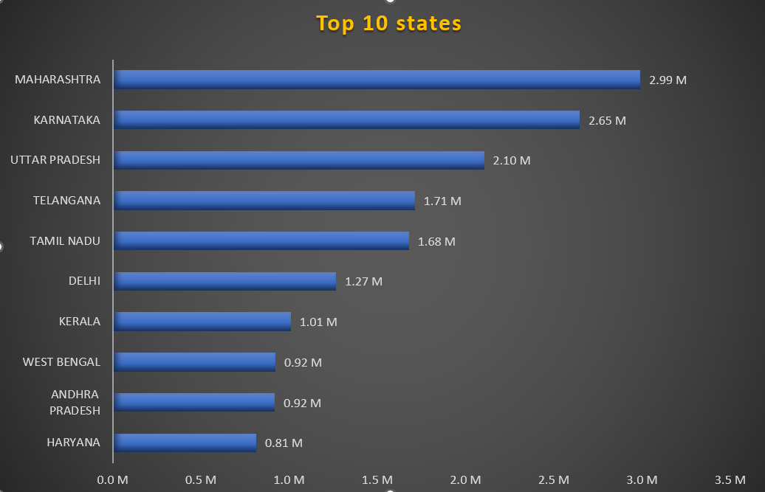

* Women are more likely to buy compared to men (~65%)

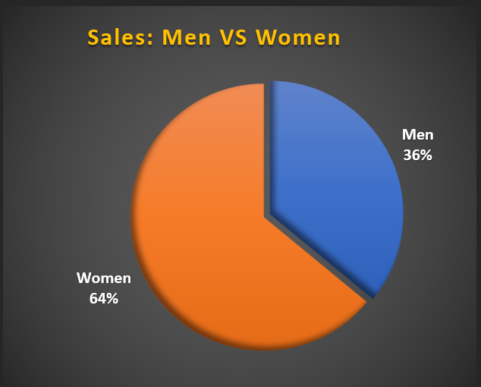

* Adult age group (30-49 years) is max contributing (~50%)

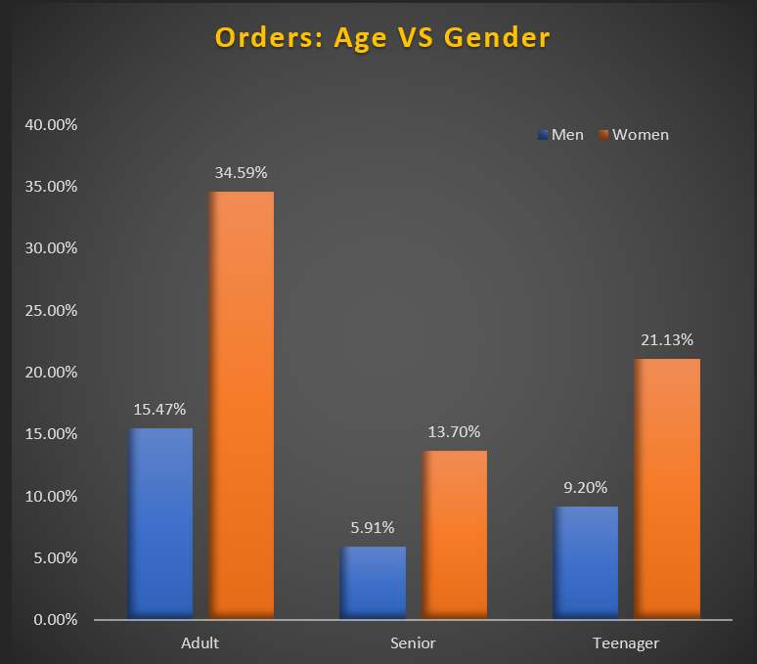

* Amazon, Flipkart and Myntra channels are max contributing (~80%)

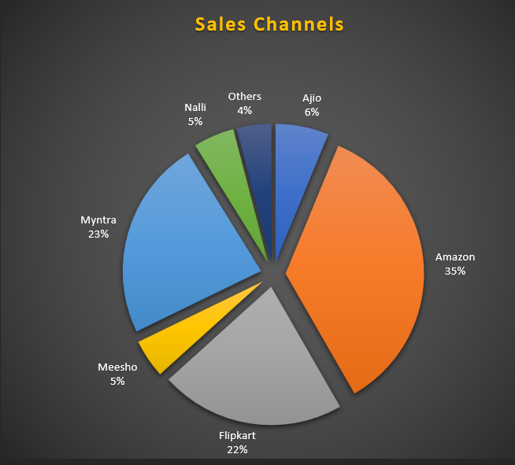

* **Sales decreases in end of the year.**

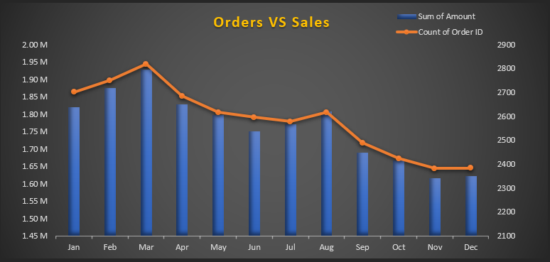

**Suggestion to improve store sales:**

* Target women customers of age group (30-49 years) living inMaharashtra, Karnataka and Uttar Pradesh by showing ads/offers/coupons available on Amazon, Flipkart and Myntra.
* Launch a year end sale, to increase sales in year-end months.

**Excel dashboard link:** [E-commerce analysis Dashboard.xlsx](E-commerce%20analysis%20Dashboard.xlsx)

